# Introduction to Computer Science and Programming 1

# CSCI120

### Sample Final Exam

**Note:** This document has been designed and developed as part of an initiative for creating an OER (Open Education Resource) package for the course CSCI 120 at Columbia College.

Please contact [Alireza.davoodi@gmail.com](mailto:Alireza.davoodi@gmail.com) for any comment, modification, and questions.

**Terms of use:** Please feel free to customize this document as needed

Last Modified: July 2022

**Problem 1**

* Use hand-tracing (debugging table) to understand what this flowchart does.
* Write a Python Program for the following flowchart.
* What is the time complexity of this flowchart?

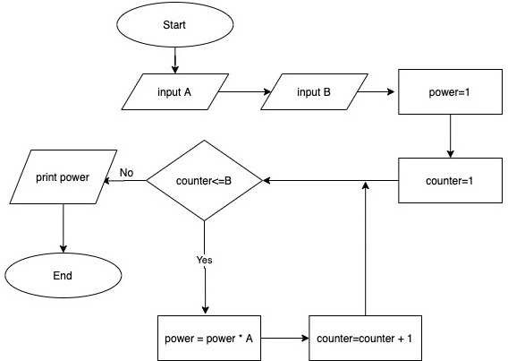

**Problem 2**

* Develop an Object-Oriented design for the following image. (What classes would you define? What properties (if any)? What methods (if needed)?
* Write python code that shows what you see in this image (products, price, code, shelf…)

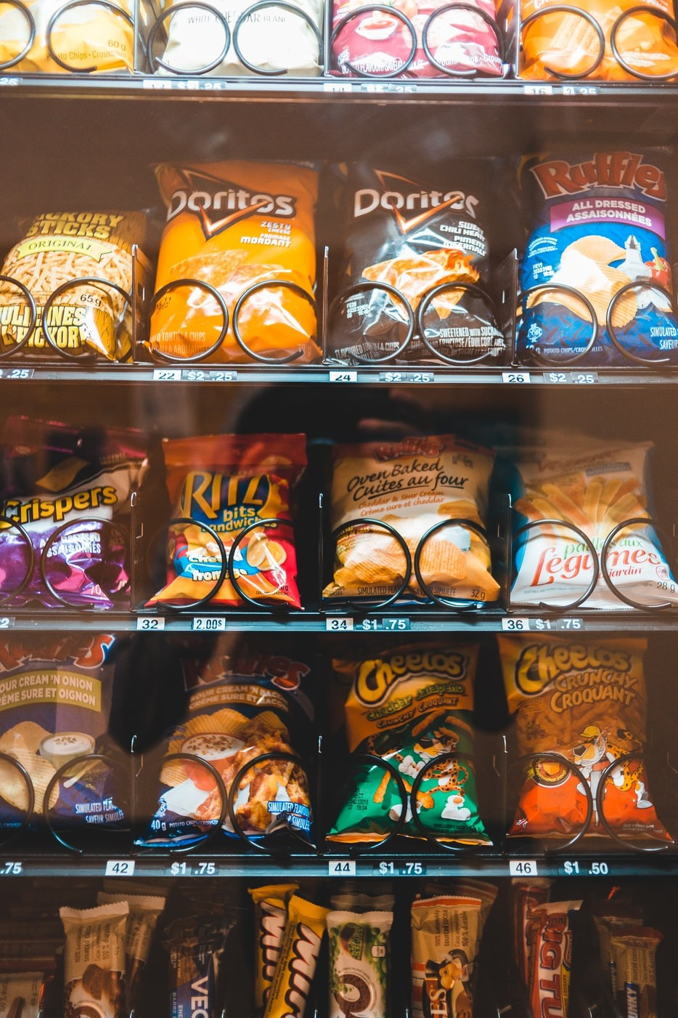

**Problem 3**

* What data structure would you use to store the information shown in the following image?

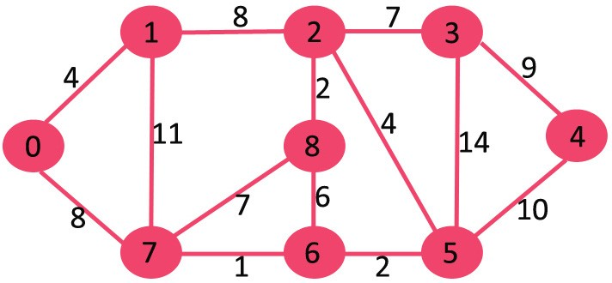

* Using the data structure(s) you defined, write a method for each of the following problems. Also describe what is the time-complexity order of your methods.
* A method, called print which prints the information in the above figure.
* A method called, remove, which removes one node from the above shape. When a node is removed, all its connections should be removed too. For instance if Node 6 is removed all the connections from and to Node 6 should be removed.
* A method called, add which adds a node and connections to the above shape.

**Problem 4**

* Suppose the following figure shows the share of each brand in the mobile market.
* Define a class that models the information in the following figure (in other word, define the class and its properties (instance variables)) and then define the following methods:

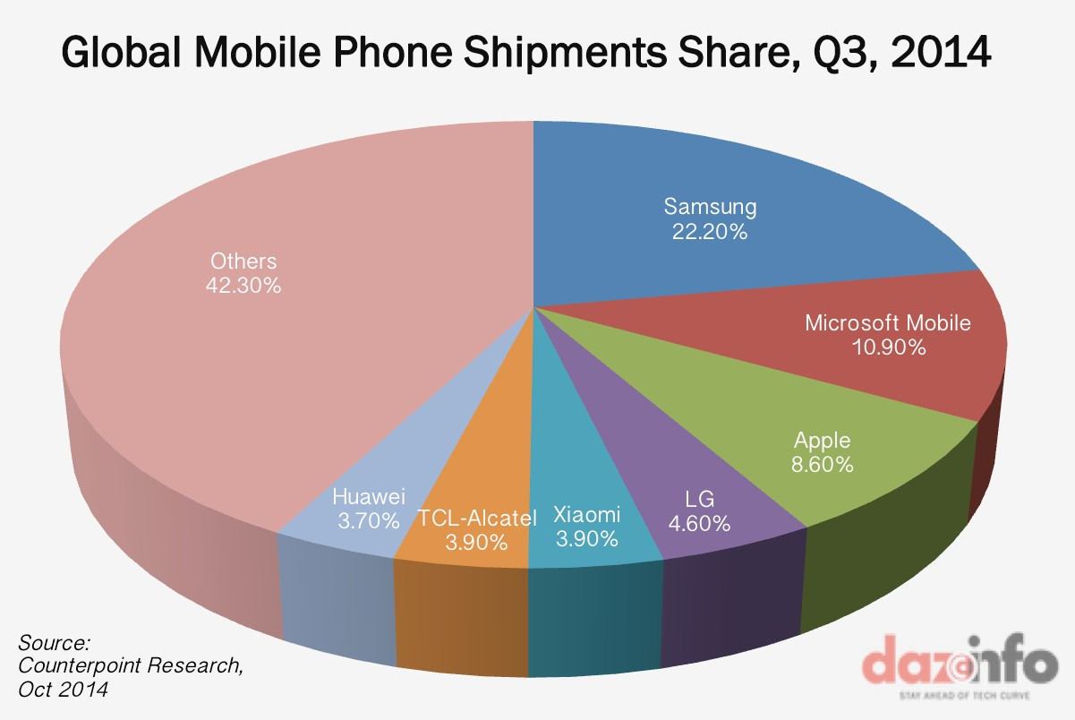

* Add an instance method called *updateShare* which receives a brand and a number (which shows the share of that brand in mobile market) and update the chart information.
* Add an instance method called *assignShare* which receives two brands and assign the share of the first brand to the second one and updates the chart.
* Add a static (class) method which receives the chart information and returns the brand with maximum share in market.

(self, polynomialEquation1, polynomialEquation2):

**Problem 5**

* Write a python program with the following description:
  + Define a class called MyCustomList.
  + The class has an instance variable called myList which is a list of integers.
  + Define the following instance methods for the class:
  + addItem: It has an input of type int and it add the number to the list if this number already does not exist in the list. If it exits it will ignore it.
  + calculateSum: It has no input and will return the sum of all numbers in the list.
  + calculateMax: it has no input and will return the maximum number of the list.
  + printList: It has no input but print the current content of the list to the out.
  + Remember to define a constructor for this class.
* Define another class called Test MyCustomList. This class has a static method called testMyCustomList. This method is used to contain a test scenario for the MyCustomeList.
* In another python file, define a main function and use the TestClass to test the MyCustomeList class.

**Good** **Luck** ☺